SOFTWARE CONSTRUCTION AND DEVELOPMENT
OPEN ENDED LAB
LAB TASK:
Generics:
Implement a generic class for representing a Loan in the Loan Management System. Utilize generics to allow flexibility in the type of loan amount (e.g., Integer, Double).
Mutability and Immutability:
- Create two versions of the Loan class:
- Mutable Loan: Allow modification of loan details after initialization.
- Immutable Loan: Design an immutable version of the Loan class where loan details cannot be modified once set.
Abstract Data Type (ADT): Implement an abstract data type for managing a collection of loans. This ADT should provide methods for adding loans, retrieving loans, and calculating the total loan amount. Exception Handling:
Implement exception classes for handling specific scenarios in the Loan Management System. For example, create a custom exception for cases where an attempt is made to modify an immutable loan. Unit Testing:
Write comprehensive unit tests for the Loan Management System. Cover different scenarios, such as creating loans, adding them to the collection, attempting to modify immutable loans, and handling exceptions. Utilize a testing framework (e.g., JUnit) for efficient and organized testing.

- IMMUTABLE LOAN.JAVA:

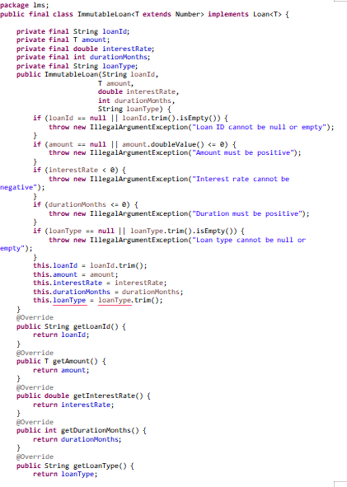

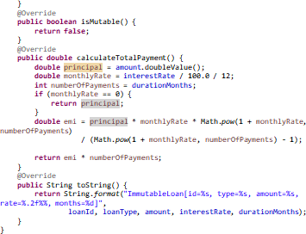
- IMMUTABLELOANMODIFICATIONEXCEPTION.JAVA:
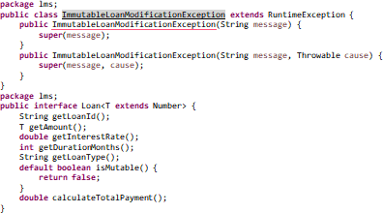
- LOAN.JAVA(INTERFACE):
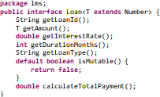
- LOANREPSITORY.JAVA:

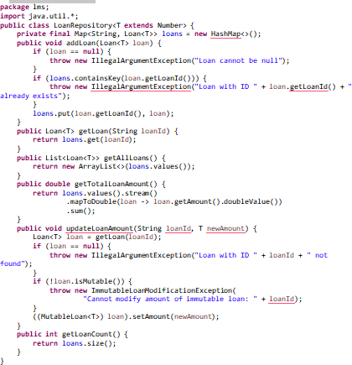
- LOANSYSTEMDEMO.JAVA:
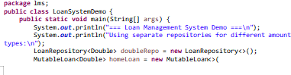
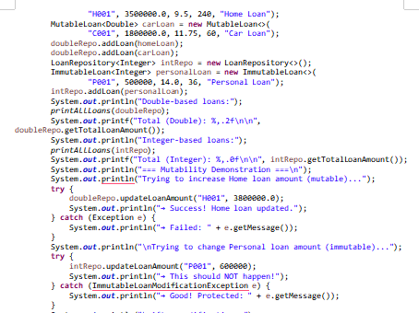

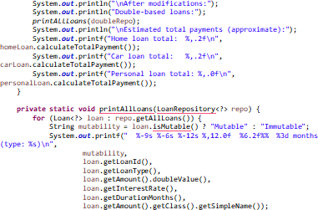
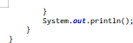

- MUTABLELOAN.JAVA:
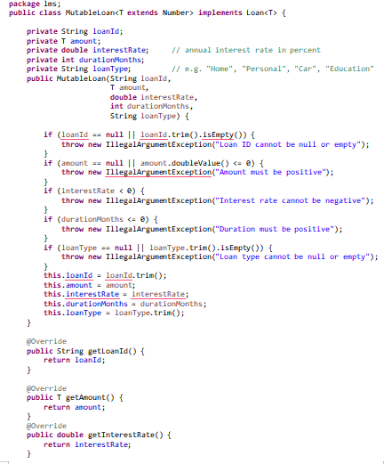

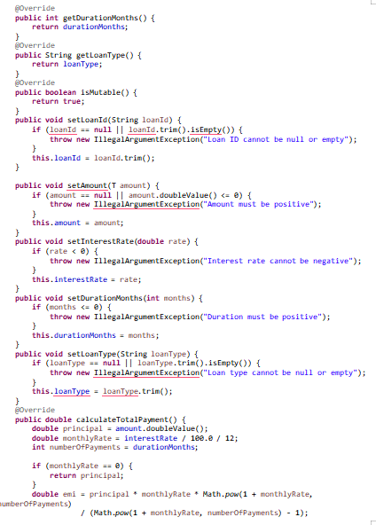
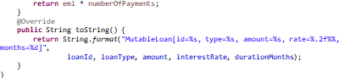

- LOANMANAGEMENTSYSTEMTEST.JAVA(JUNIT)

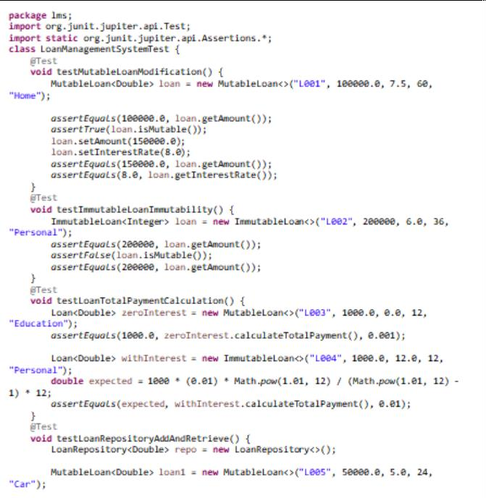
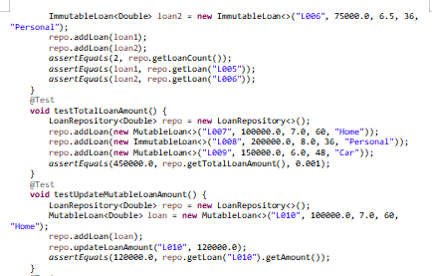

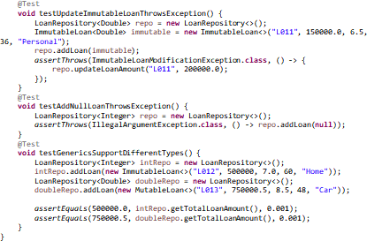
OUTPUT:
